SMART WATER FOUNTAINS

**Project Objectives:**
- 1. **Water Quality Monitoring:** Incorporate sensors to measure parameters such as pH, turbidity, and temperature in the water.
- 2. **Water Consumption Tracking:** Implement flow meters to track water usage in real-time.
- 3. **Remote Control:** Enable users to control the water fountains via a mobile app or web interface.
- 4. **Data Analytics:** Collect and analyze data to optimize water usage and detect anomalies.
- 5. **Sustainability:** Promote water conservation through responsible usage.
**IoT Device Setup:**
- 1. **Sensors:** Install water quality sensors (e.g., pH and turbidity sensors) and flow meters at the water fountains.
- 2. **Microcontrollers:** Use IoT-compatible microcontrollers like Arduino or Raspberry Pi to collect data from sensors.
- 3. **Connectivity:** Connect the microcontrollers to the internet using Wi-Fi or cellular modules for data transmission.
- 4. **Power Supply:** Ensure a stable power supply, possibly using solar panels or mains power with battery backup.
- 5. **Security:** Implement security measures to safeguard the devices and data from unauthorized access.
**Platform Development:**
- 1. **Data Storage:** Set up a database to store sensor data securely.
- 2. **IoT Cloud Platform:** Utilize a cloud-based IoT platform (e.g., AWS IoT, Google Cloud IoT, or Azure IoT) to manage device connectivity, data ingestion, and control.
- 3. **User Interface:** Develop a web or mobile app for users to monitor water quality, consumption, and control the fountains.
- 4. **Data Analytics:** Implement algorithms for data analysis and visualization to derive insights.
- 5. **Security and Authentication:** Ensure robust security and user authentication mechanisms to protect data and control access.
- 6. **Notifications:** Implement notifications/alerts for users to receive updates about water quality or consumption issues.
- 7. **Scalability:** Design the platform to handle an increasing number of devices and users.
- 8. **Integration:** If necessary, integrate the platform with other systems or smart home platforms for a seamless user experience.
**Code Implementation:**
Using python
import RPi.GPIO as GPIO
import time
# Set up GPIO pins
water_sensor_pin = 17
water_pump_pin = 18
GPIO.setmode(GPIO.BCM)
GPIO.setup(water_sensor_pin, GPIO.IN)
GPIO.setup(water_pump_pin, GPIO.OUT)
# Main loop
try:
while True:
if GPIO.input(water_sensor_pin) == GPIO.HIGH:
print("Water level is low. Turning on the water pump.")
GPIO.output(water_pump_pin, GPIO.HIGH)
else:
print("Water level is sufficient. Turning off the water pump.")
GPIO.output(water_pump_pin, GPIO.LOW)
time.sleep(1) # Check water level every second
except KeyboardInterrupt:
GPIO.cleanup()
**Circuit Diagram**

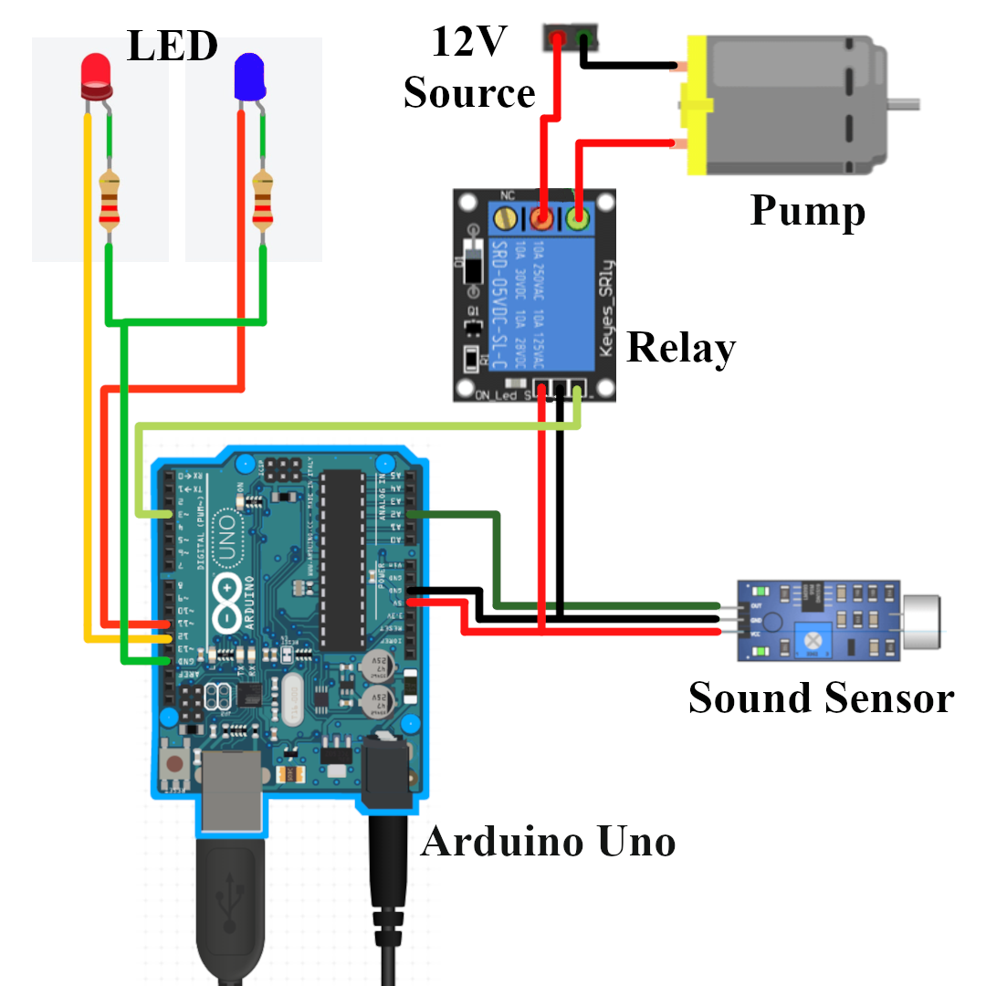

**Block Diagram**:

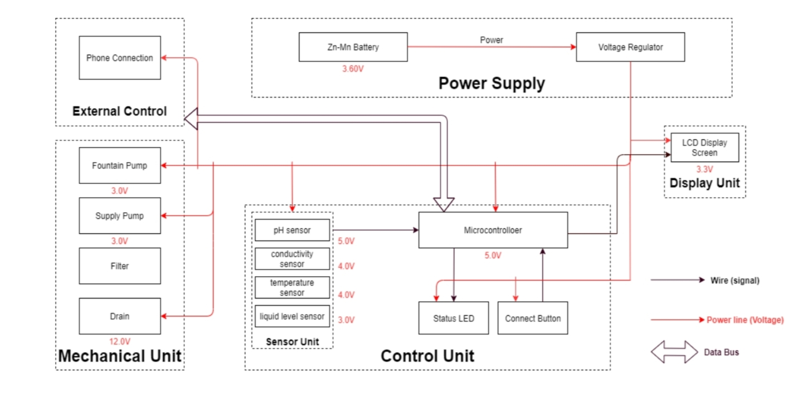
**Conclusion**:
The smart water fountains project represents a significant advancement in the field of public health and sustainability. By incorporating technology and data-driven solutions into the design of water fountains, we have created a system that promotes hydration, reduces single-use plastic waste, and provides valuable insights for efficient maintenance. This project not only enhances the quality of life for communities but also contributes to a more environmentally responsible and connected world.

